

**MUSANZE CAMPUS**

**COLLEGE OF SCIENCE AND TECHNOLOGY**

**SCHOOL OF ICT**

**DEPARTMENT OF COMPUTER SCIENCE**

**PROJECT REPORT:**

**CRIMINAL INVESTIGATION USING FACE RECOGNITION BASED ON DEEP LEARNING ALGORITHMS**

**Submitted by:**  
***MUROKOZI Jackson:*** ***219006818***

***BYIRINGIRO Bertin: 21900535***

***KASINE Peninah:*** ***219003832***

**Under supervision of**:

**BIZIMUNGU Theogene**

Submitted in partial fulfillment of the requirements for the award of   
**BACHELOR OF SCIENCE DEGREE IN INFORMATION SECURITY**.

**November 2022**

# **CERTIFICATION**

*This is to certify that the Project Work entitled,* **“CRIMINAL INVESTIGATION USING FACE RECOGNITION BASE ON DEEP LEARNING ALGORITHMS”** *is a record of the original bona fide work done by* **Mr. *MUROKOZI Jackson Reg. No 219006818*, Mr. *BYIRINGIRO Bertin Reg. No* 21900535, Mrs. *KASINE Peninah Reg. No* 219003832** *in partial fulfillment of the requirement for the award of Bachelor Degree in Computer science with an option of information security in University of Rwanda, college of science and technology during the Academic Year 2021-2022.*

Supervisor **Mr. BIZIMUNGU Theogene**

Signature: Date: --/--/2022

Head of Department of Computer Science Dr. Alfred UWITONZE

Signature……………………Date: ……. /……./……..

# **DECLARATION**

We do hereby declare that the project work " **CRIMINAL INVESTIGATION USING FACE RECOGNITION BASE ON DEEP LEARNING ALGORITHMS** "submitted in partial fulfillment of the requirements for the bachelor degree in computer science with options information security conducted under the guidance of **Mr. BIZIMUNGU Theogene**, is the record of our own work and has never been presented or submitted for any academic award in any University or Institution as a whole or in part.

Declared By

***MUROKOZI Jackson ………......................................................***

***BYIRINGIRO Bertin ...................................................................***

***KASINE Peninah ……................................................................***

University of Rwanda -CST

*Date……. /………/…….. And Signature…………………………*

# **DEDICATION**

We dedicate this work to:

* The Almighty God,
* Our families,
* Our friends and colleagues,
* Rwanda National Police,
* University of Rwanda,
* Our Lecturers,
* Our supervisor

# **ABSTRACT**

We are all aware that our face is a distinct and important feature of the human body structure that defines a person. With this advantage, we developed a system which use that uniqueness to determine the identity of a criminal. With the advent of technology, the system will use the installed CCTV in numerous public areas to catch criminals. The criminal face recognition system will be created using previously collected faces and criminal photos accessible at the RIB (Rwanda Investigation Bureau). In this paper, we present an android application for criminal investigation using face recognition based on deep learning algorithms to be used by the Investigation Bureau in order to improve and upgrade criminal differentiation in a more effective and efficient manner.

By using the advanced technology, this system will improve the present system while taking criminal detection to a whole new level by automating scanning of human faces to identify criminals. Face recognition technology was used, and the CCTV cameras continuously captures photos and analyze them to detect human faces from the live video. The collected photographs of the person entering that location is compared to the criminal data in our database. If the person's face capture by CCTV cameras matches, the system will display their image on the admin’s screen and display a message with their name indicating that the criminal has been located and is present in that specific location. And the system will alert the admins of RIB and also notify the police agents with access to catch the identified criminal.

**TABLE OF CONTENT**

CERTIFICATION 1

DECLARATION 2

DEDICATION 3

ABSTRACT 4

LIST OF FIGURES 8

LIST OF ABBREVIATIONS 10

CHAP I: GENERAL INTRODUCTION 11

1.1 Introduction 11

1.2 Problem Statement 12

1.3 Objective of the Study 12

1.3.1 General Objectives 12

1.3.2 Specific objectives 12

1.4 General Interests 13

1.5 Scope and Limitations of the System 13

1.6 Technologies 14

1.7 Organization of the report 15

1.8 Project Gantt Chart 16

CHAP II: LITERATURE REVIEW 17

2.1 Definition of Terminologies 17

2.1.1 Criminal 17

2.1.2 Face Recognition 17

2.1.3 Open-CV 17

2.1.4 Convolution Neural Network 17

2.2 Existing System 17

2.3 Proposed System 18

2.4 Computer Vision Algorithms used 19

2.4.1 CNN Algorithm 19

2.4.2 TensorFlow 20

2.4.3 Eigenfaces Approach using PCA Algorithm 20

CHAP III: RESEARCH METHODOLOGY 22

3.1 Introduction 22

3.2 Methodological Approach 22

3.2.1 Documentation method 22

3.2.2 Sampling method 23

3.3 Requirement Analysis 23

3.4 Class diagram 25

3.4.1 Symbol Used for Class diagram 25

3.5 Sequence Diagram 28

3.6 System Requirements 29

3.6.1 Hardware requirements 29

3.6.2 Software requirements and development tools 29

CHAP 4: ANALYSING, DESIGN, AND IMPLEMENTATION OF THE PROJECT 31

4.1 Introduction 31

4.2 Entity relationship diagram 31

4.3 Database schema 32

4.4 System Analysis 33

4.5 Working Principle of the System 33

4.6 System Implementation 34

4.6.1 Overview of system interface for CCTV Camera application 34

4.6.2 Overview of system interface for agent’s android mobile application 40

4.6.3 Overview of system interface for admin’s website dashboard 43

CHAP V: CONCLUSION & RECOMMENDATION 51

REFERENCEES 52

# **LIST OF FIGURES**

**Figure 1.1**: Types of Identification system 12

**Figure 2:** Gantt chart 16

**Figure 3**: Existing System 18

**Figure 4:** Proposed System 19

**Figure 5**: CNN - Convolutional neural networks 20

**Figure 6**: Face Recognition Using Eigenfaces 21

**Figure 7:** Waterfall model 24

**Figure 8:** Use Case diagram 28

**Figure 9:** Sequential diagram 29

**Figure 10:** Entity relationship diagram 31

**Figure 11:** Database Schema diagram 32

**Figure 12:** Landmarks on Every Face 33

**Figure 13:** Block Diagram of face recognition 34

**Figure 14:** CCTV Camera - Options 36

**Figure 15:** CCTV Camera - Training 38

**Figure 16:** CCTV Camera - Scanning 40

**Figure 17:** Agent - Login screen 41

**Figure 18:** Agent - Dashboard screen 42

**Figure 19:** Agent - Notification alert 43

**Figure 20:** Admin - Login page 44

**Figure 21:** Admin - Dashboard page 45

**Figure 22:** Admin – Criminals list page 45

**Figure 23:** Admin - Face Database page 46

**Figure 24:** Admin - Tracking page 47

**Figure 25:** Admin - CCTV Camera page 47

**Figure 26:** Admin - Reports page 48

**Figure 27:** Admin - Agent Access page 49

**Figure 28:** Admin – Add/Edit an Agent 49

**Figure 29:** Admin - Statistics page 50

# **LIST OF ABBREVIATIONS**

AES: Advanced Encryption System

AI: Artificial Intelligence

AIS: Automatic Identification System

CCTV: Closed-Circuit Television

CNN: Convolutional Neural Network

CV: Computer Vision

IDE: Integrated Development Environment

JDK: Java Development Kit

MD5: Message-Digest algorithm 5

MIS: Manual Identification System

ML: Machine Learning

NPC: National Police College

Open-CV: Open-Source Computer Vision Library

OS: Operating System

RIB: Rwanda Investigation Bureau

RNP: Rwanda National Police

SDK: Software Development Kit

SQL: Structured Query Language

# **CHAP I: GENERAL INTRODUCTION**

## **Introduction**

Criminal identification is the most vital work for the investigation bureau who are looking for criminals, but it is also the most difficult and time-consuming task since they must locate it everywhere. It is more challenging in densely populated cities or public locations. In certain circumstances, manual identification allows for the gathering of additional information about criminals.

Criminal identification can no longer be a challenge because of existing of advanced technologies in computer vision and images processing where machine learning and artificial intelligence are used with different computer vision algorithms to detect, recognize and identify objects and human faces from a picture or video. As a solution, this research presents an automated criminal identification method based on identifying criminals' faces.

This will help the investigation bureau in identifying and apprehending offenders in public locations [1]. Criminal identification can be accomplished in two methods, as seen in Figure 1.1 Identification in the Manual Identification System (MIS) is done by the investigation bureau officers searching them in public locations. It takes a long time to offer sufficient attention, and it also carries the risk of missing criminals because they would be alerted by seeing officers and quickly escape from there. Because the MIS is taking extra time, we will not be able to adequately focus on everyone. When it comes to an automatic identification system (AIS), however, there is no requirement for public surveillance. All of the processes in this system are automated.

**Identification System**

**Manual Identification System  
(MIS)**

**Automatic Identification System  
(MIS)**

**Figure 1.1**: Types of Identification system

* 1. **Problem Statement**

It is still a difficult and challenging for the investigation bureau to track and find people who have committed sins or people who are suspect of a certain crime. There is a burden in using manual or analog ways of posting pictures of criminals on different platforms, social media or in public waiting for someone to recognize and identify a criminal and call the investigators to come to catch the identified criminal. The processing of the current used strategy is very slow, budget and time consuming. As bad results, it takes too long to track and find the criminals which sometimes give a chance to those criminals to commit crimes again resulting to loss of life and properties. The investigation bureau also spends a lot of money during the process which can end up in a loss. On the other hand, criminals can hide or change their identifications and they can no longer be identified easily. These are caused by not using advance technology to support the investigation and criminals’ identification such as using Computer Vision, AI (Artificial Intelligence), and Machine Learning.

* 1. **Objective of the Study**

### **1.3.1 General Objectives**

The general objectives of our project are to develop an advanced system which identify criminals using face recognition technologies provided by computer vision and enhanced by deep learning algorithms. The system capture and analyses images extracted from different real-time surveillance camera and are handled by image processing, and then compared with the images stored in the database. If images match, the alert will be sent to the administration of the system and to the nearest police station so that the identified criminal gets caught.

### **1.3.2 Specific objectives**

The specific objectives of our project are to:

* Develop a system which can help to identify criminals to support the investigation bureau.
* Develop a system which is accurate and fast to be used in criminals’ identification.
* Develop a system which uses computer vision technology to identify criminals.
* Develop a system which can automatically adopt to change in behaviours of the environment by using Artificial Intelligence (AI) and Machine Learning (ML).
  1. **General Interests**

The interests of our project are:

* Developing a system which can be used by RIB (Rwanda Investigation Bureau)
* Using advanced technologies in criminal identification system.
* Applying knowledge, we covered in information security to give our hands in the existing challenge of identifying criminals in a secured, safe and fast way.
* Extending the application of computer vision technology by implementing it in our developed android based secured criminals’ identification system.
  1. **Scope and Limitations of the System**

The developed system has some scope and limitation. The area in which our research is based in Rwanda. And our case study focused on conducting a research based on Rwanda Investigation Bureau. We shall investigate the current strategy done by RIB and RNP to track and identify criminals who are suspect of a crime or criminals who have committed illegal activities in a way of improving the current used system.

The function of the developed system is to recognize and identify criminals based on recognizing their faces. The system uses a real-time camera which capture video and the system process it into continuous pictures and the by using computer vision algorithms as Open CV and Convolution Neural Network, the captured pictures are processed and compared with those stored in the database.

In the development of our system, we have used the camera of android devices as CCTV camera in our demonstration and working principle of our system.

* 1. **Technologies**

To achieve the desired output of the system, it is developed using different technologies, different programming languages, algorithms and security.

Proposed programming languages to use are:

* Python
* Java
* JavaScript
* XML
* HTML
* CSS

Database and query scripts used:

* MySQL
* Firebase

Computer vision algorithms used:

* Open CV
* CNN (Convolutional Neural Network)

The system security measures taken to enforce security on our system by protecting data sent within the system:

* The administration dashboard is secured so that only users with admin privileges can access it through the website dashboard.
* In case a criminal is detected, the system alerts automatically the system admins and the nearest police stations and the policemen so that they can catch the identified criminal.
* The passwords are encrypted using MD5 hashing
* They system uses computer vision technology to detect and identify human face
* The system easily adapts to environment changes with the help of Artificial Intelligence and Machine Learning

## **1.7 Organization of the report**

This document is composed of 5 chapters classified as follows:

**Chapter 1**, this chapter provides an overview of the entire project where it contains the general

introduction, background, statement of the problem, choice and motivation of the study, general

objective, specific objectives, scope of the study.

**Chapter 2**, this chapter focuses on describing the current system environment mentioning the

and analyzing how it works and the problems related to it.

**Chapter 3**, this chapter describes the methodology used by the researcher to achieve the stated

objectives and techniques used to collect data. It helped us the researcher by proving real data

from documents and people’s experience provided guidance to the system solution.

**Chapter 4**, this chapter presents proposed implementation of the system by explaining how it works, expected results and different diagrams.

**Chapter 5**, this chapter provide conclusion basing on the conducted research and the outcomes

and recommendations to different parties that could be interested in or get advantages from the

system.

## **1.8 Project Gantt Chart**

**Figure 2:** Gantt chart

# **CHAP II: LITERATURE REVIEW**

# **2.1 Definition of Terminologies**

### **2.1.1 Criminal**

What qualifies someone as a criminal? A criminal is a common phrase for someone who has committed a crime or has been legally convicted of committing a crime. Criminal also refers to being involved in a crime. Criminal activities or individuals are those who are involved in or connected to a crime. [2]

### **2.1.2 Face Recognition**

A facial recognition system is a technology that can match a human face from a digital image or video frame against a database of faces. It is often used to verify users via ID verification services and works by locating and measuring facial characteristics from a given image.[3]

### **2.1.3 Open-CV**

Open-CV is an acronym for Open-Source Computer Vision Library. The library comprises over 2500 optimized algorithms, including a complete range of both traditional and cutting-edge computer vision and machine learning approaches. It also provides C++, PYTHON, JAVA, and MATLAB interfaces that work with Windows, Linux, Android, and Mac-OS. Open-CV is free to use for both business and non-commercial purposes. Open-CV is used to capture photos and videos in public places. [4]

### **2.1.4 Convolution Neural Network**

CNN is a powerful algorithm for image processing. Their algorithms are currently the best existing algorithms for the automated processing of images. They are being used in different place to do things like identifying the objects in an image.

## **2.2 Existing System**

Normally the current system in Rwanda, we have RIB (Rwanda Investigation Bureau) which is the agency responsible to tracking and finding criminals who have committed illegal activities and it can assign tasks to RNP (Rwanda National Police). The way criminals’ identification is performed, is that RIB posts the picture of criminals on the platforms, social media and also, they put different publication in the news, and post banners of their faces in different places so that when someone recognize a criminal basing on the posted photo, he/she can call the investigation bureau. In this case, there can be no accuracy because it is hard to remember someone you saw in a picture, memorize him/her and be able to match the identification with someone you saw in the public. Also, the identification can take to long to find the criminals. [5]

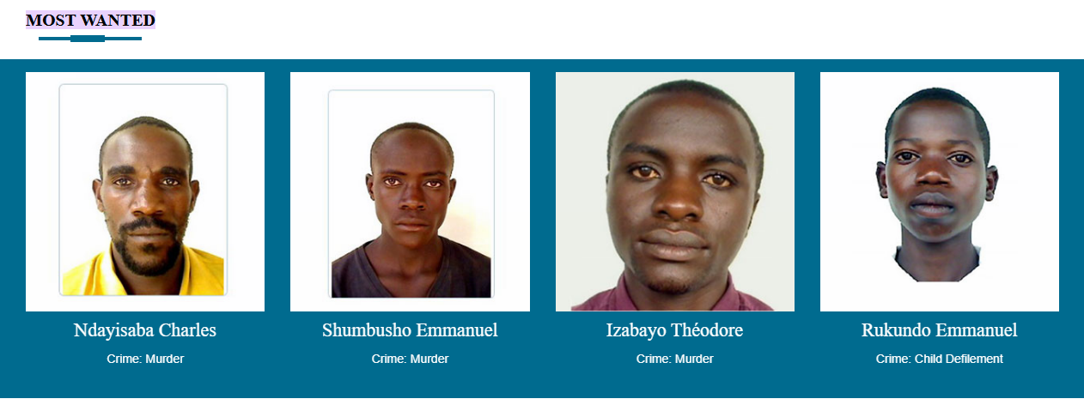

**Figure 3**: Existing System

## **2.3 Proposed System**

In this paper, we use CCTV cameras that are always recording in a public setting. During the system's implementation, we will save criminal photos data with their names on photographs in the database. We will process those photos and extracting features from them, and during feature extraction, and we will be grabbing the face encodings from the current images and storing them into a single file using Android device technology. Using open-CV while capturing CCTV footage and captured images face encodings are placed and compared with our saved face encodings of the criminal database if any match is found then automatically on screen it will display an image of that criminal whose face matches and display the message with his name that criminal found and give an alert to the concerned agency of investigation bureau and also notify the nearest policemen so that they can catch the identified criminal.

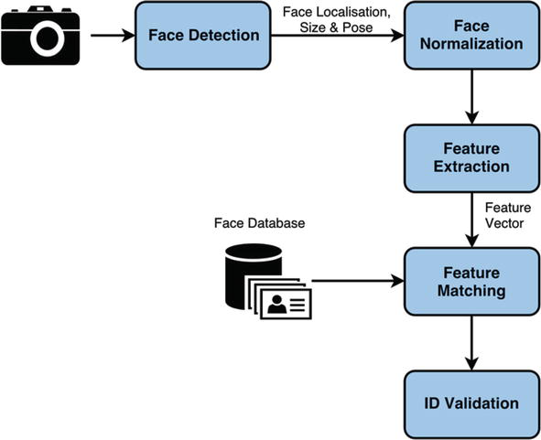

**Figure 4:** Proposed System

## **2.4 Computer Vision Algorithms used**

### **2.4.1 CNN Algorithm**

Convolutional neural network is a particular kind of neural network for working with images which takes input from an image, extracts feature from the image, and then provides learnable parameters to effectively do the tasks of classification, detection, and many other things. It utilizes something called "filters" to extract the features from the photographs; different filters are used to extract different information from the images.

CNN is widely used for a variety of computer vision applications, including image classification, object recognition, picture segmentation, and many more. It uses binary classification or multi-class classification to extract information from the images and labelling or categorizing the images following a couple of steps:

Step: - 1: Importing the necessary libraries

Step: - 2: Loading the data and basic EDA

Step: - 3: Preparing the training and testing data

Step: - 4: Building the Model

Step: - 5: Compile and Train the Model

Step: - 6: Evaluating the model

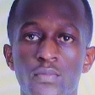

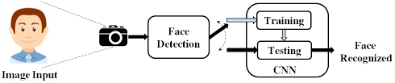

**Figure 5**: CNN - Convolutional neural networks

### **2.4.2 TensorFlow**

TensorFlow is a widely used and highly regarded open-source Python package from Google that makes building computer vision deep learning models straightforward and easy. With TensorFlow, the process of gathering data, training models, delivering predictions, and improving future outcomes is made easier by Google Brain TensorFlow. It is an open-source libraries for numerical computation and large-scale machine learning.

### **2.4.3 Eigenfaces Approach using PCA Algorithm**

Dimensionality reduction and linear algebra techniques are used in this approach for face recognition. This method was employed at the time in a variety of applications, including handwriting recognition, lip reading, medical picture analysis, etc. since it was simple to use and had lower processing costs. It reduces dimensionality and projects training sample/data into tiny 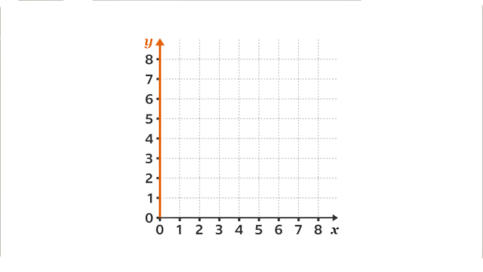feature space using Eigenvalues and Eigenvectors.

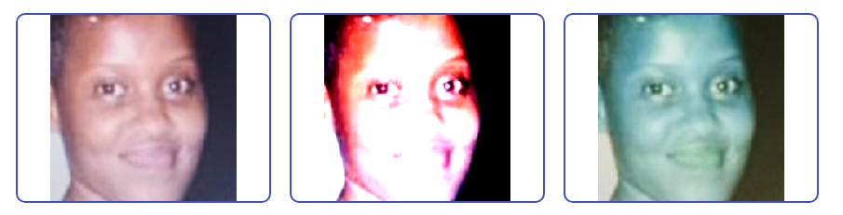

**Figure 6**: Face Recognition Using Eigenfaces

**Advantages**:

* Simple to implement and less expensive in terms of computing.
* No prior knowledge of the image is necessary, such as face features

**Limitations**:

* For training/testing, a correctly cantered face is necessary.
* The algorithm is sensitive to the amount of light and shadow in an image as well as the size of the face.
* This algorithm must have a front view of the face in order to function effectively.

# **CHAP III: RESEARCH METHODOLOGY**

## **3.1 Introduction**

A research method is a specific process or method used to identify, select, process, and analyze information about a topic. Scientifically it must be forced to be analyzed and consider their causes, solutions, explanations and applications. Analysis in particular helps us to understand nature and natural phenomena. And we use "qualitative research".

This chapter describes the development side of “Criminal Investigation Using Face Recognition Based on Deep Learning Algorithms” it encloses a brief overview of the technologies used to make our system, tests have been applied. And also specify software compatibility requirements.

## **3.2 Methodological Approach**

A methodology is a broad research approach that describes how the study will be carried out and, among other things, specifies the method to be employed. Methodology describes these approaches, which specify the means or method of data gathering or the way of obtaining a certain outcome. The methodology does not identify a specific methodology, but significant emphasis is placed on the type and type of process, or objective, to be followed in a certain procedure.

In our study we are expecting to use the following data collection methods:

1. Documentation

2. Sampling

### **3.2.1 Documentation method**

Documentation, as you know, is the process of reading a library book and browsing the Internet. Information about them relevant to our topic or inquiry. To obtain a bibliographic search on a topic, use this procedure. Some researchers are interested in researching on a subject that shares some similarities with ours. The information gathered will assist us in developing your project.

### **3.2.2 Sampling method**

Specifications for selecting the population to be included in the survey. As a general rule, use the sampling method. Sampling can be defined as the process of selecting a sample from a particular species or group of people for research purposes. Sampling is the process of dividing a population into a series of parts called sampling units. This sample deals with a population reference to our topic. For example, the scope we have covered is detecting criminals using face recognition.

## **3.3 Requirement Analysis**

**Software Development Life Cycle**

The process that serves as the framework for software development is known as the SDLC, or software development lifecycle. The SDLC serves as a guide for project managers and business organizations as they complete each phase of the software development lifecycle. A phase is the name for each stage of the SDLC. The SDLC's initial step is the requirements collecting and analysis phase.

**Waterfall model**

The waterfall approach was the first SDLC model widely used in software development to ensure project success. The "waterfall" approach divides the entire software development process into individual phases. In this waterfall model, the result of one phase typically serves as the input for the next sequential phase.

The following figure shows the different phases of the waterfall model.

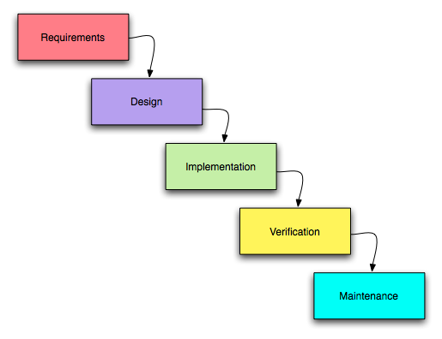

**Figure 7:** Waterfall model

The successive phases of the waterfall model are 7:

* **Requirements extraction and analysis**: In this phase, all possible requirements for the system to be developed are recorded and documented in the specifications.
* **System design**: In this phase, the specifications of the first phase are investigated and the system design is prepared. This system design helps specify hardware and system requirements and helps define the overall system architecture.
* **Implementation**: With input from the system design, the system is first developed in small programs, so-called units, and integrated in the next phase. Each unit is developed and tested for its functionality. This is called a unit test.
* **Integration and testing**: All units developed during the implementation phase will be integrated into the system after each unit has been tested. After integration, the entire system is tested for errors and failures.
* **System offering**: As soon as functional and non-functional tests are completed. The product is used in your environment or put on the market.
* **Maintenance**: There are some issues with the client environment. Patches have been released to address these issues. Also, some better versions will be released to improve the product. Maintenance is performed to bring these changes to your environment.

All of these phases are cascaded and progress is considered to be steadily flowing downwards (like a waterfall) through the phases. The next phase is named "Waterfall Model" because it only starts when the goals defined in the previous phase are achieved and approved. In this model, the phases do not overlap.

### **3.4 Class diagram**

A class diagram in the Unified Modeling Language is a form of static structural diagram that illustrates a system's classes, their properties, operations, and relationships between objects in order to describe the system's structure.

### **3.4.1 Symbol Used for Class diagram**

|  |  |
| --- | --- |
| **An actor:**   * Is a person or system that derives benefit from and is external to the subject. * Is depicted as either a stick figure (default) or, if a nonhuman actor is involved, a rectangle with   “Actor” in it (alternative).   * Is labeled with its role. * Can be associated with other actors using a specialization/super class association, denoted by an arrow with a hollow arrowhead. Is placed outside the subject boundary. | Actor Name |
| **A subject boundary:**   * Includes the name of the subject inside or on top. * Represents the scope of the subject, * e.g., a system or an individual business process. | |  | | --- | | **System Name** | |
| **An include relationship:**   * Represents the inclusion of the functionality of one-use case within another. * It has an arrow drawn from the base Use Case to the used Use Case. |  |
| **An extend relationship:**   * Represents the extension of the Use Case to include optional behavior. * Has an arrow drawn from the extension Use Case to the base Use Case |  |
| **A generalization relationship:**   * Represents a specialized Use Case to a more generalized one. * Has an arrow drawn from the specialized Use Case to the base Use Case? |  |
| **An association relationship:**   * Links an actor with the Use Case (s) with which it interacts. |  |

**Table 1:** Use Case tools description

***Design of the diagram: Use Case***

**CCTV CAMERA**

**ADMIN**

**POLICE AGENT**

**RIB**

**AGENT**

**Figure 8:** Use Case diagram

### **3.5 Sequence Diagram**

The Sequence Diagram model is the collaboration of objects based on a time sequence. That shows how the objects interact with others in a particular scenario of a use case. With the advanced visual modeling capability, you can create complex sequence diagram without an obstacle.

This figure explains the sequence of user interaction with a system

**RIB & POLICE AGENT**

**ADMIN**

- Add criminals faces,

- Train the system,

- Start tracking to a criminal

**CCTV CAMERA**

Send faces detection reports

Receive notification for criminal detections

Display out to admin dashboard

**Figure 9:** Sequential diagram

## **3.6 System Requirements**

### **3.6.1 Hardware requirements**

The system hardware required are:

* Computers such as laptops, desktop, android phones
* RAM with 4GB minimum
* Processor: Intel core or i3 of 2.9HZ minimum, etc
* Hard Disk with 500GB minimum

### **3.6.2 Software requirements and development tools**

The software required are:

* Android studio
* Android SDK
* Open-CV library
* JDK
* WampServer or XAMPP, MySQL
* Text editor like VSCode
* Firebase
* System type 32 bit or 64bit
* Operating System (OS): Windows 8,8.1,10, and windows 11

# **CHAP 4: ANALYSING, DESIGN, AND IMPLEMENTATION OF THE PROJECT**

## **4.1 Introduction**

This chapter contains two main parts: the design and implementation of the criminal investigation using face recognition based on deep learning algorithms for RIB as the administrators and the CCTV application for scanning. This chapter explains and demonstrate the projects using screenshots and diagrams including user case diagrams, ER diagrams, and user interfaces.

## **4.2 Entity relationship diagram**

This entity relationship diagram details the tables in the database, the entities, and a description of each table.

**CRIMINAL**

**ADMIN**

**CCTV CAMERA**

**AGENT**

CONTROL

VIEW ALERTS

DETECTION

**Figure 10:** Entity relationship diagram

## **4.3 Database schema**

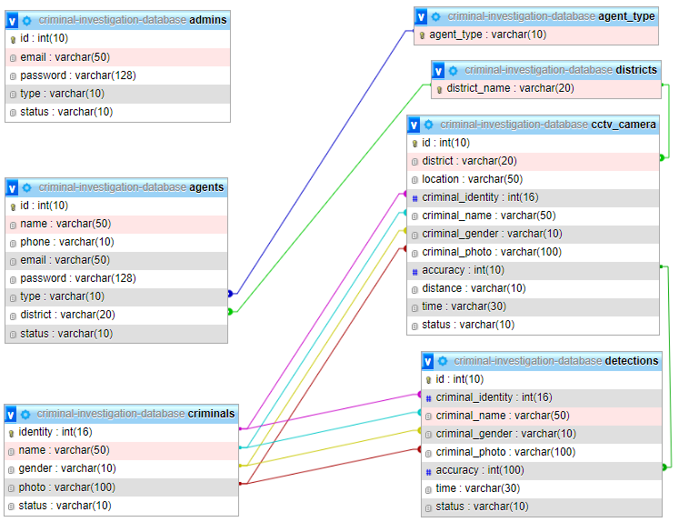A database schema is the logical representation of a database, which shows how the data is stored logically in the entire database. It contains list of attributes and instruction that informs the database engine that how the data is organized and how the elements are related to each other.

**Figure 11:** Database Schema diagram

## **4.4 System Analysis**

Criminal enrollment is the first stage in recording criminal information in the criminal database. Criminal identities, names gender and images are recorded in the database then face recognition and identification is conducted using the recorder images and information. Using the face detection algorithms, picture of criminals’ face encodings will be used. The database procedure is criminal enrollment, but the major step begins with facial detection. As seen in Figure below, face detection takes into account 68 landmarks on the face. CCTV camera collected film or picture is saved, and its properties, such as encodings, are extracted before being compared to image encodings in the database. The face will be matched in the database, and the name and the criminal detected message will be shown beside the criminal image on the screen in the CCTV Room.

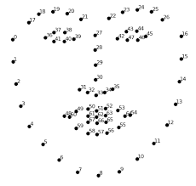

**Figure 12:** Landmarks on Every Face

## **4.5 Working Principle of the System**

We are employing CCTV cameras to capture photographs of members of the public in order to identify the appropriate person who has a criminal record in the database to apprehend.

1. First, we extract the facial encodings from the criminal database photos and save them in one list, while dividing the name recorded with the criminal image into another list.

2. Then the CCTV Camera are deployed to collect public pictures in order to identify and easily apprehend criminals who are present in public places.

3. Taking the acquired photos' face-encodings and extracting the features from them.

4. Using our database image encoding values to compare captured picture encoding values.

5. If the encoding values match those of the taken image, the criminal image, name, and message are shown on the screen.

6. The image of that individual are saved to a separate folder, allowing investigation bureau to readily identify the criminal whose identification matches.

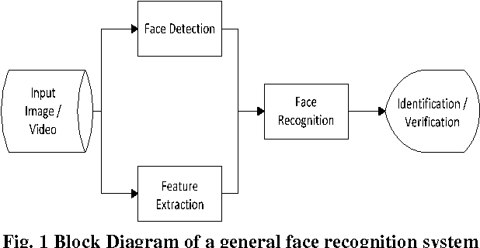

**Figure 13:** Block Diagram of face recognition

**4.6 System Implementation**

**4.6.1 Overview of system interface for CCTV Camera application**

The interfaces to be demonstrated are implemented in the android mobile application which act as a CCTV camera device. It is used to capture people’s faces and use the computer vision algorithm to identify and recognize criminals.

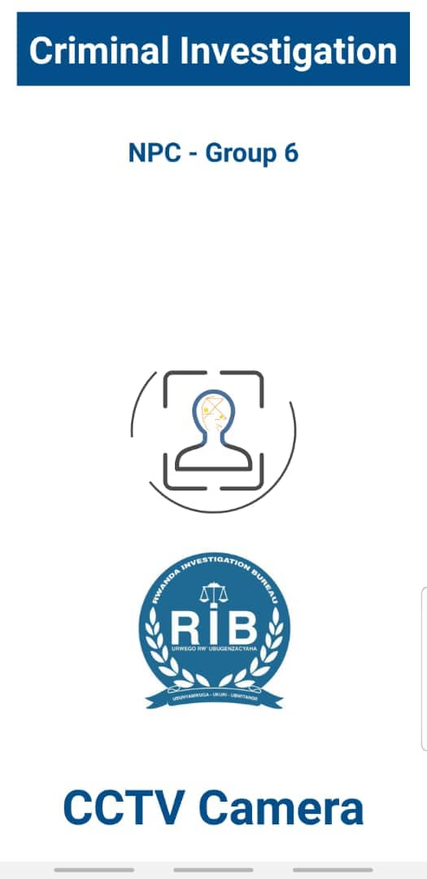

**CCTV Camera – Options**

The CCTV Camera provide different options mainly its purpose is to train criminals face for further recognitions and saving recognitions data in the database.

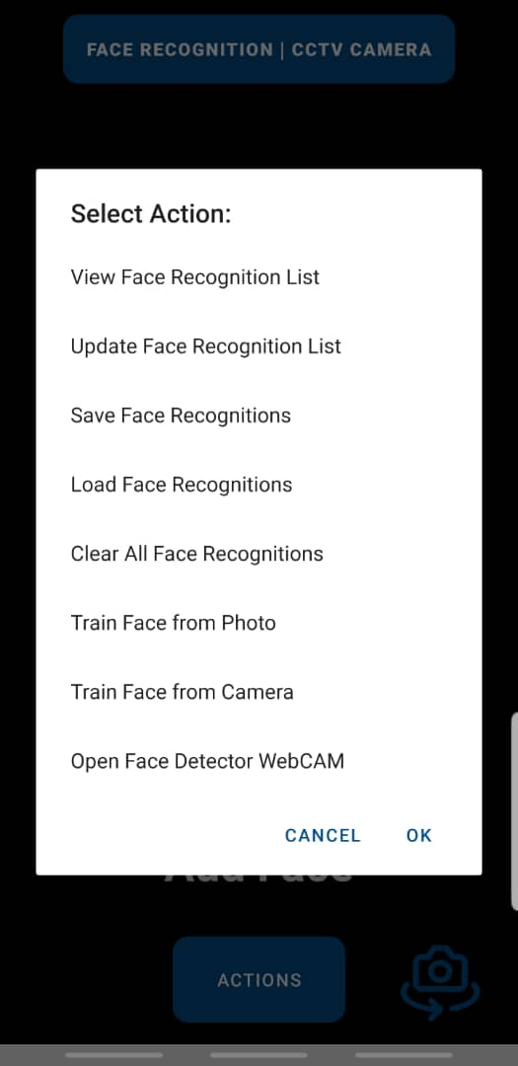

**Figure 14:** CCTV Camera - Options

**CCTV Camera – Training**

From the CCTV Camera, that’s where the admin can register faces of criminals either by using a camera or saved photos. After training the criminal, you provide the information corresponding to the trained face such as the identity, the name and the gender to be saved in the database.

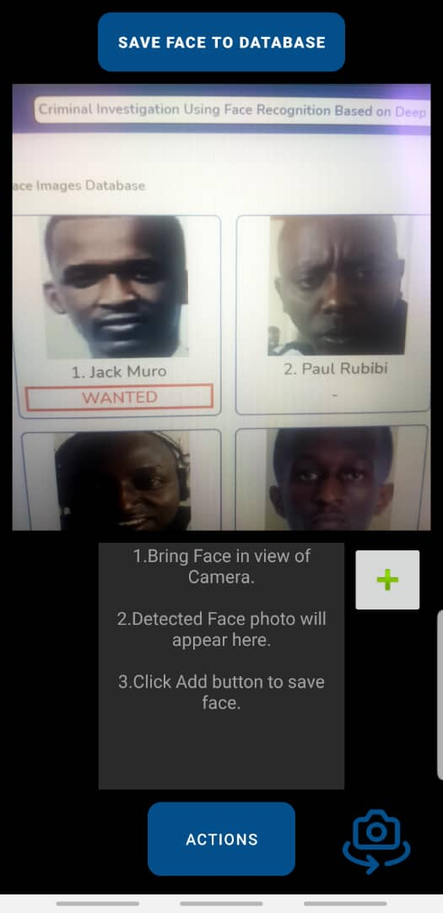 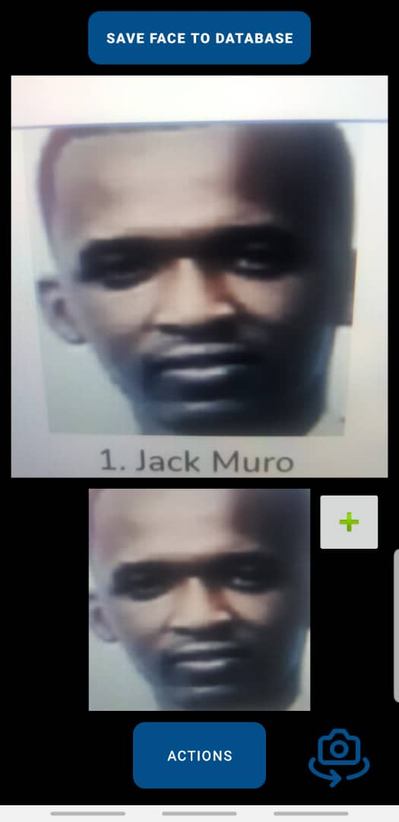

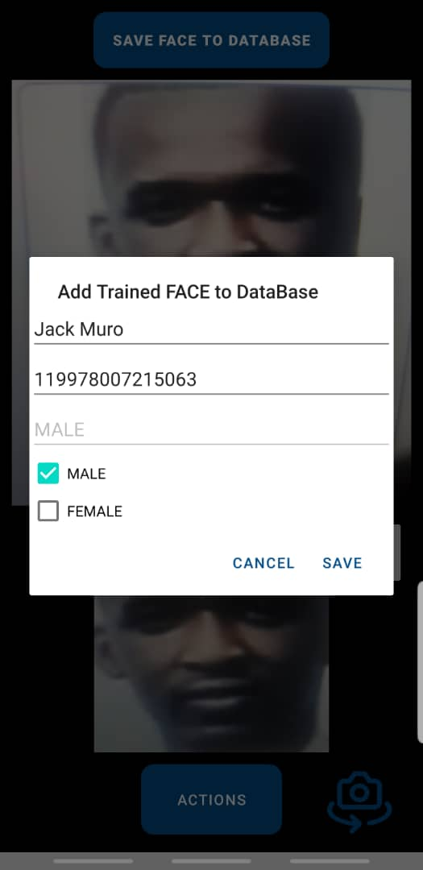

**Figure 15:** CCTV Camera - Training

**CCTV Camera – Scanning**

The CCTV Camera also performs the scanning of people face with a live video scanning, and by using computer vision algorithm, it is able to identify a human face and compare it with the registered faces in the database and hence it recognizes criminals and send the information to the administration dashboard.

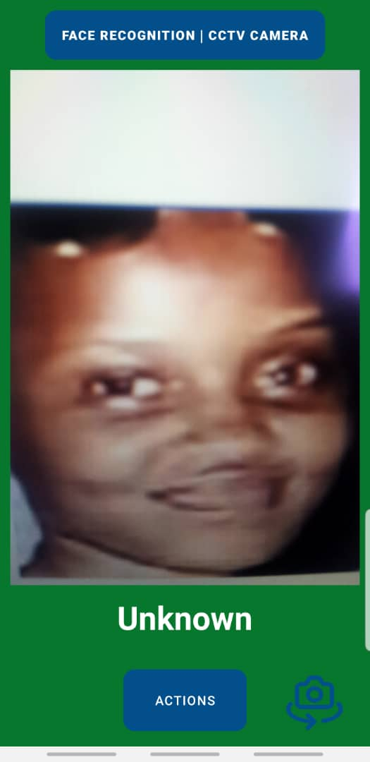 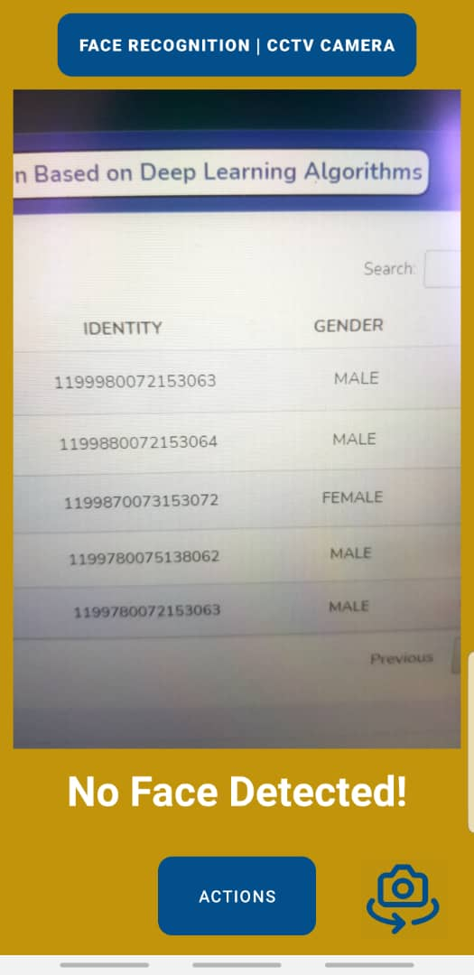

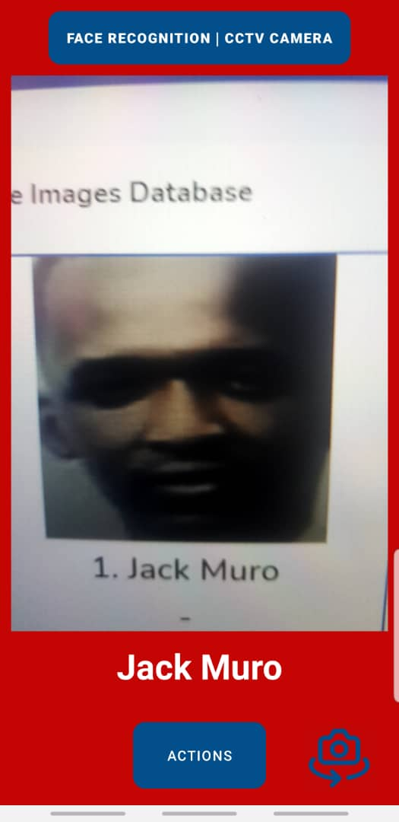 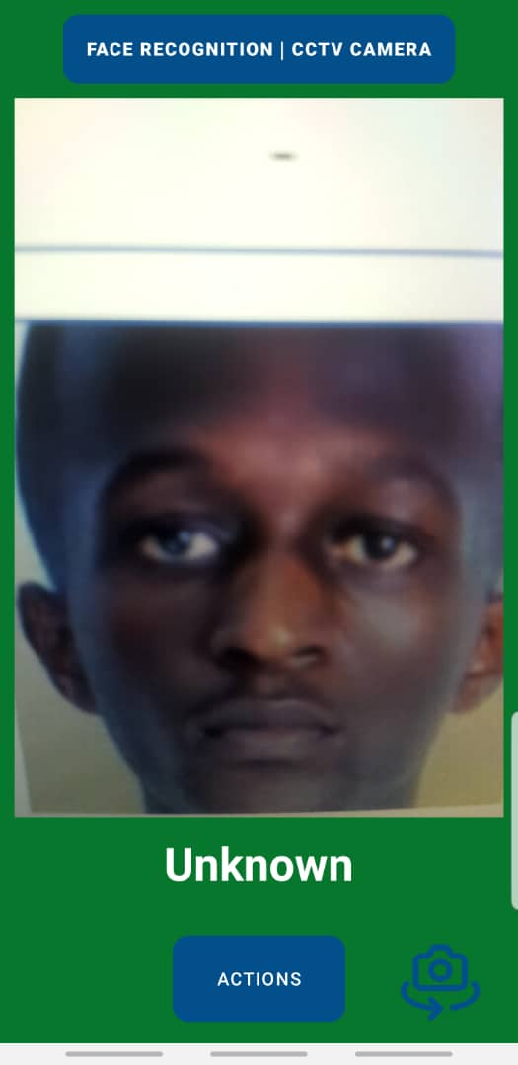

**Figure 16:** CCTV Camera - Scanning

**4.6.2 Overview of system interface for agent’s android mobile application**

The interfaces to be demonstrated are implemented in the android mobile application of the agents, which is gives registered and authorized RIB and police agents to access information in the system.

**Agent – Login screen**

For the agents to access the agent mobile application, they have to be registered by the admin and verify their email and also get approved by the admin. To be authenticated, the agent must provide their email and password.

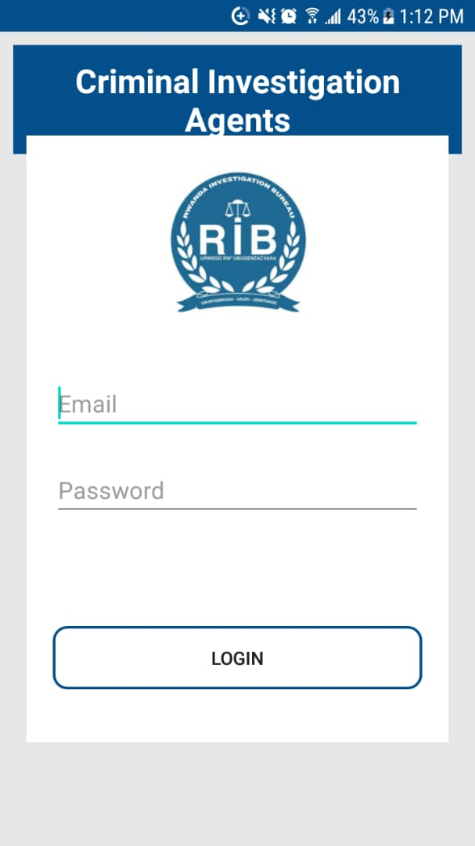

**Figure 17:** Agent - Login screen

**Agent – Dashboard screen**

After logging in, the agents are taken to their dashboard screen in the application where they can be able to view data captured by the CCTV Camera is the location that are assigned to. In case a tracked criminal is detected, the agents of RIB or Police are be able to see it on their smartphones.

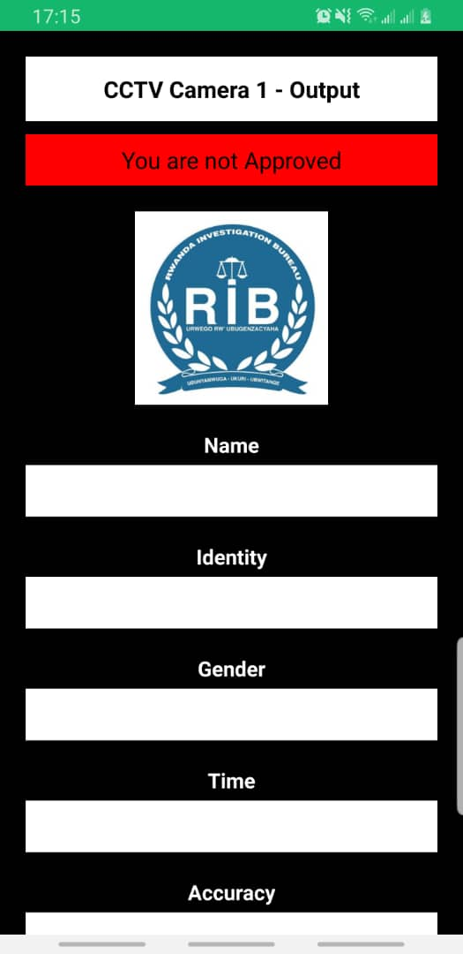 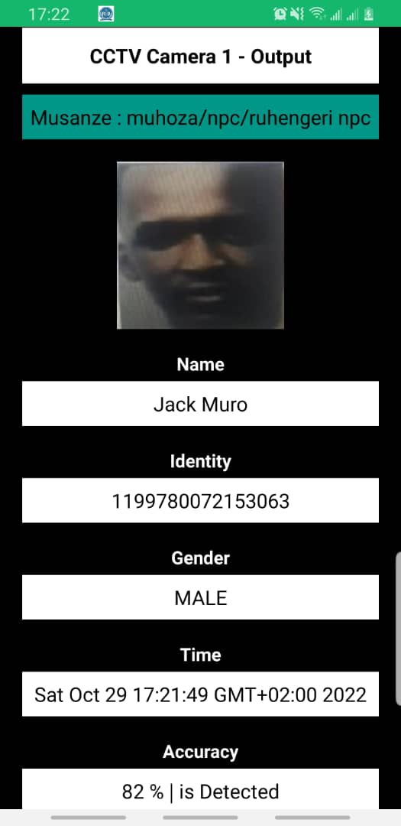

**Figure 18:** Agent - Dashboard screen

**Agent – Notification alert**

On the agent application, once a criminal who is being tracked is detected and recognized, a notification alert is sent to all approved agents with in the CCTV Camera location.

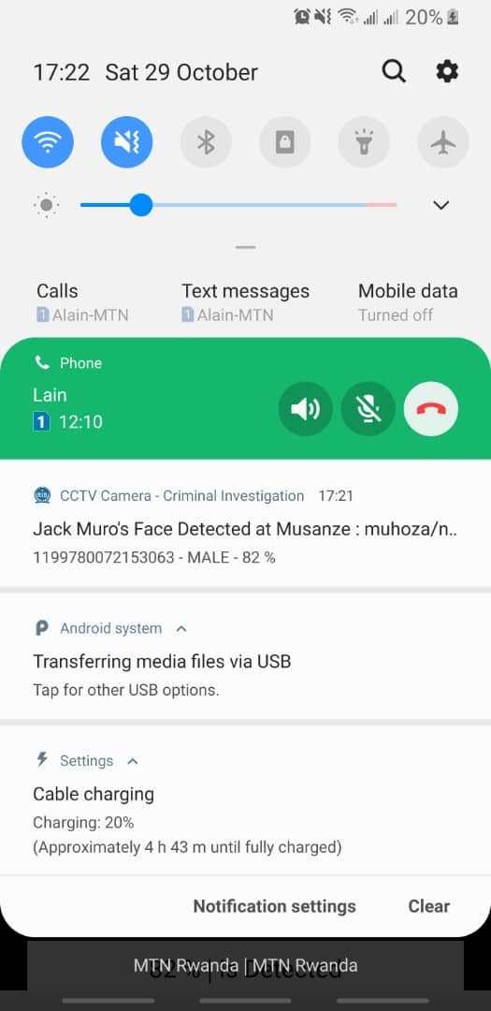



**Figure 19:** Agent - Notification alert

**4.6.3 Overview of system interface for admin’s website dashboard**

The interfaces to be demonstrated are implemented in the website dashboard which is used by only the administrators of RIB to select criminals to be tracked, to view reports of tracked and detected criminals and other statistics.

**Admin – Login page**

This is the entrance page for the administration of the system, where the admin must provide a valid email address and a security password to be able to login in the dashboard. And only registered emails with admin privileges can have access to the dashboard. In case an admin forget the password, there is also an option to reset the email where a rest password link is sent to the entered admin email address.

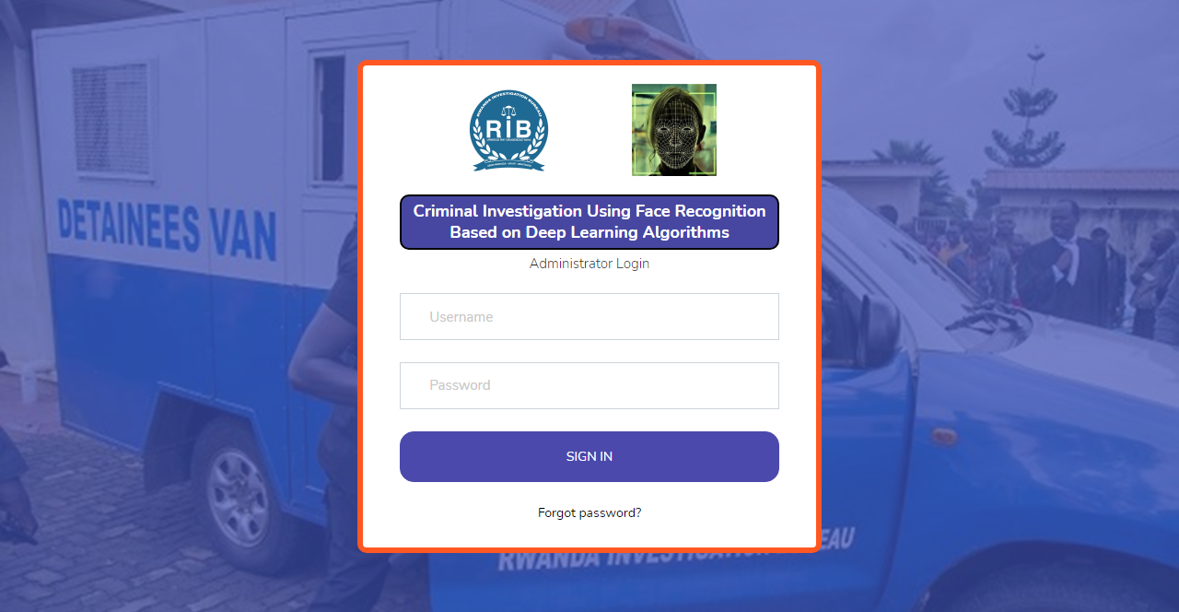

**Figure 20:** Admin - Login page

**Admin – Dashboard page**

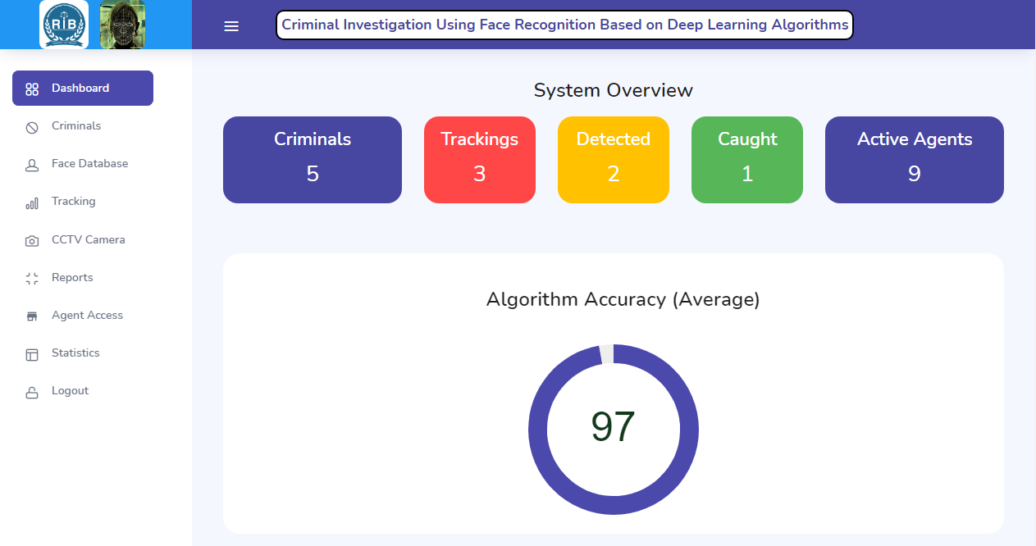

**Figure 21:** Admin - Dashboard page

**Admin – Criminals’ list page**

This is the page which list all registered criminals and their information like the photo, name, identity, the gender with an option r

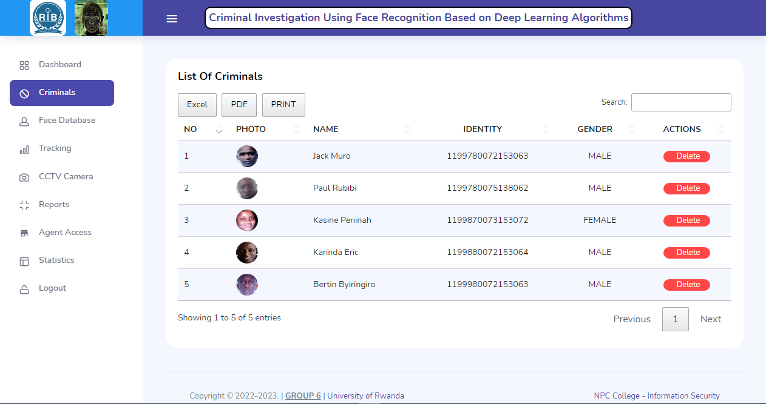

**Figure 22:** Admin – Criminals list page

**Admin – Face Database page**

The face page retrieves all faces of the registered criminals in the database by showing the last trained picture of each criminal, the name and the status whether a criminal is wanted or not.

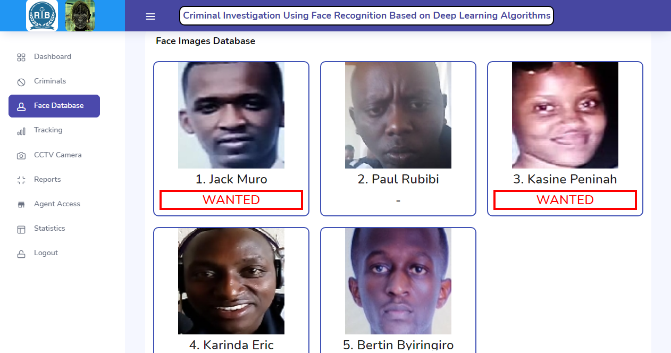

**Figure 23:** Admin - Face Database page

**Admin – Tracking page**

This a page which gives the administrator the option the start tracking a criminal and to view the status of criminals where is being tracked, detected or found.

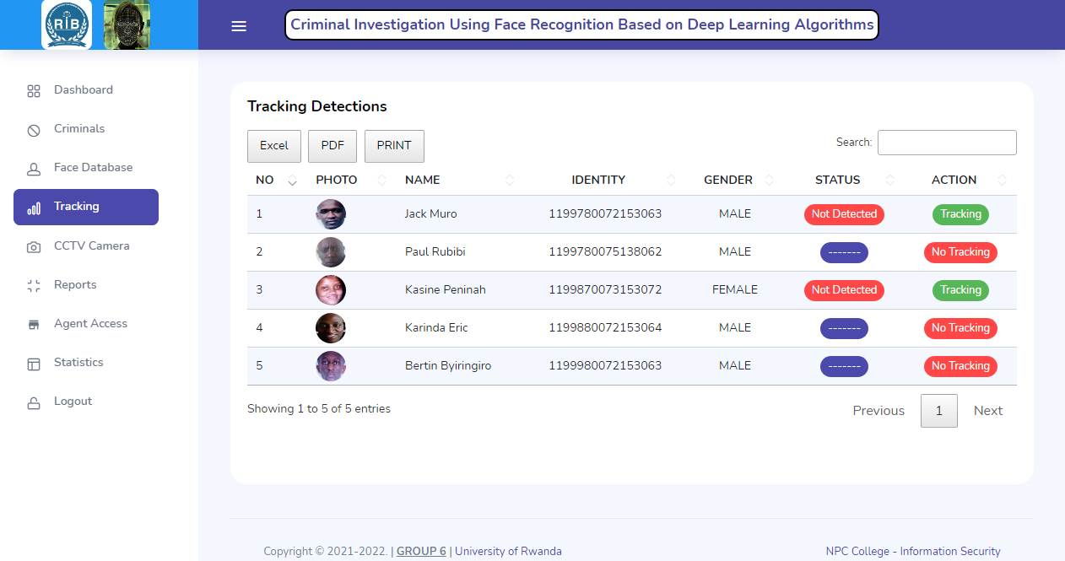

**Figure 24:** Admin - Tracking page

**Admin – CCTV Camera page**

This page shows the live output the CCTV Camera by showing the last time of detection and the information of the last recognized person like the name, gender, identity, photo and more importantly the accuracy at which the algorithm has detected and recognized that person on.

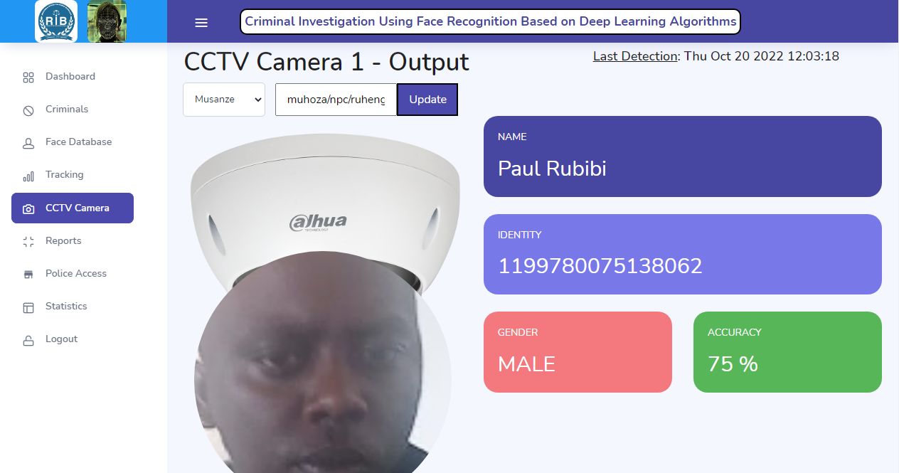

**Figure 25:** Admin - CCTV Camera page

**Admin – Reports page**

The reports page show a list of all occurred detections from the CCTV Camera by showing all retrieved information of the person or the criminal including the photo, the name, the identity, the gender, the time & date of detection and the accuracy at which the algorithm recognized the face on.

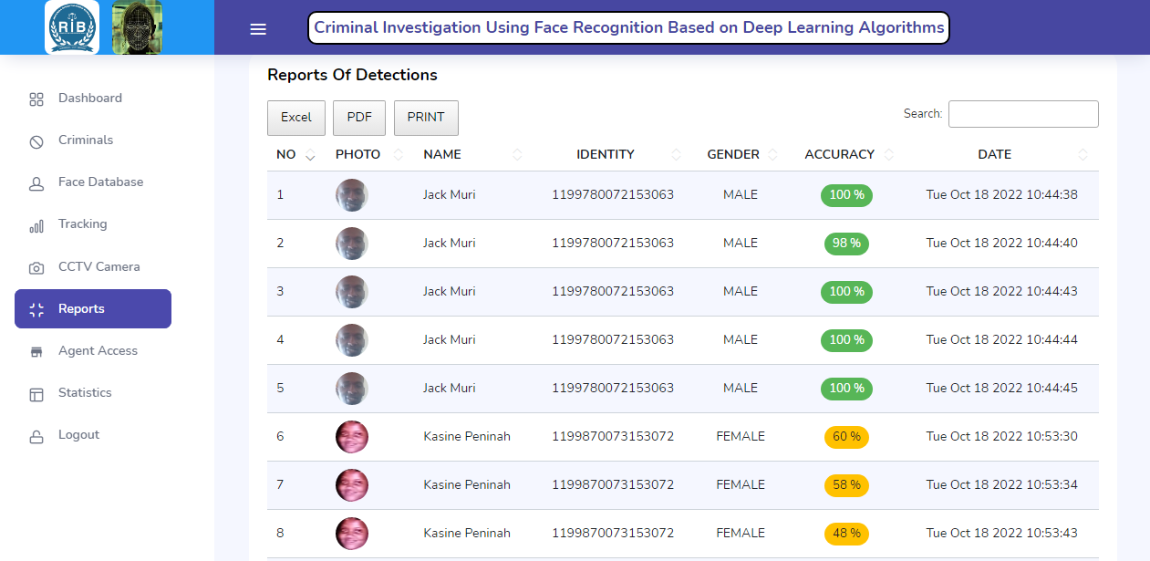

**Figure 26:** Admin - Reports page

**Admin – Agent Access page**

The agent access page shows a list of registered agents with their email, type and DPU with an option to active each agent as a way of giving them access to the agent mobile application.

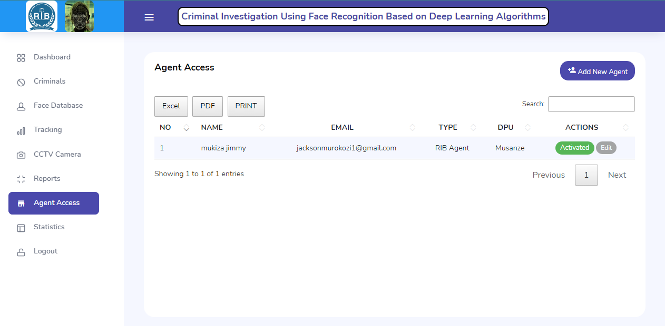

**Figure 27:** Admin - Agent Access page

**Admin – Add/Edit an Agent**

This page gives the admin an option to add a new agent by providing the agent’s name, email, type, DBU and the password. And then the system sends a rest email link for the agents to change to their own password. The admin can also use this form to modify data of an existing agent.

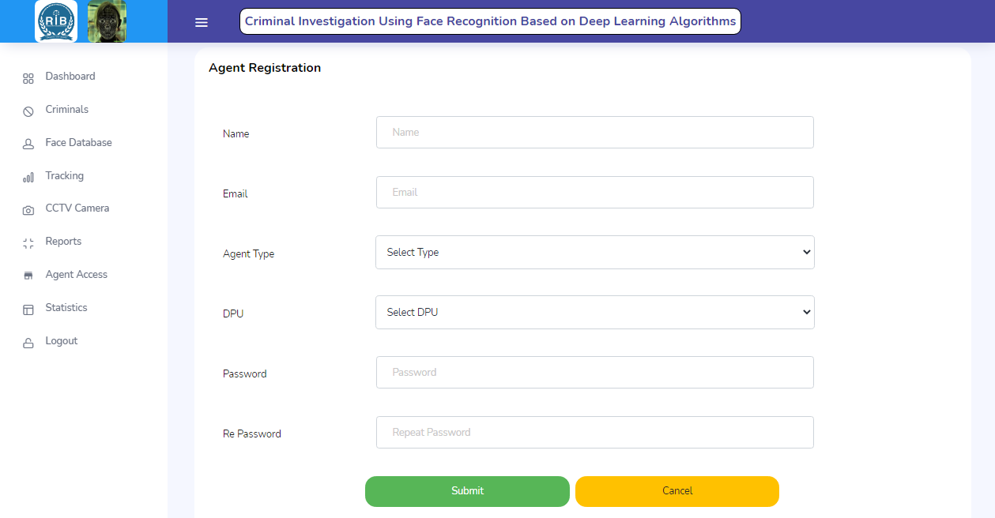

**Figure 28:** Admin – Add/Edit an Agent

**Admin – Statistics page**

The statistics page provide an overview of the system in form of graphs and analytics for instance here the pie chart show the accuracies of the algorithm where as the line graph show the rate at which the system is detecting on.

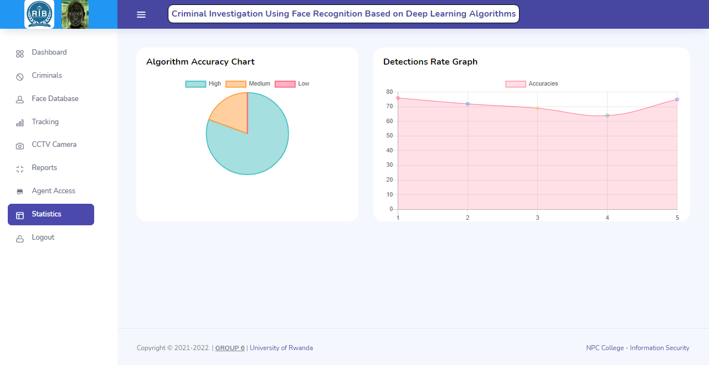

**Figure 29:** Admin - Statistics page

# **CHAP V: CONCLUSION & RECOMMENDATION**

Face Recognition Technology has the ability to aid in the resolution, prevention, and prosecution of crimes. More precisely, it might be beneficial for a variety of investigations, such as determining the identity of an ATM fraud suspect, searching for a terrorist in public places, combating child abuse, or even locating missing individuals. On the other hand, early evidence suggests that without sufficient control, face recognition technology might result in human rights violations and hurt civilians. That is why the government must be involved to ensure that it is used legally.  
  
This improved version of the criminal detection system not only makes it easier for the investigation bureau to identify criminals, but also saves them time because the processes are automated in the system. Face detection utilizing Face Encodings is the innovative aspect of this Research Paper.

For further research, we recommend that, because CCTV are static and not dynamic, we can incorporate drones which have camera to support the tracking and they might be moving around scanning people instead of waiting for the criminals to reach the place where CCTV are statically installed.

# **REFERENCEES**

[1] Ratnaparkhi, S. T., Tandasi, A., & Saraswat, S. (2021, January). Face Detection and Recognition for Criminal Identification System. In 2021 11th International Conference on Cloud Computing, Data Science & Engineering (Confluence) (pp. 773-777). IEEE.

[2] Tappan, P. W. (1947). Who is the Criminal?. American Sociological Review, 12(1), 96-102.  
[3] Tolba, A. S., El-Baz, A. H., & El-Harby, A. A. (2006). Face recognition: A literature review. International Journal of Signal Processing, 2(2), 88-103.

[4] Bradski, G., & Kaehler, A. (2000). OpenCV. Dr. Dobb’s journal of software tools, 3, 120.

[5] <https://www.rib.gov.rw/index.php?id=371#:~:text=US%20ON%20TWITTER-,MOST%20WANTED>